Insurance Price Prediction

Wireframe Documentation



Homepage

We have divided Insurance price predictor into two sections: -

1. After clicking on URL or entering the URL on search engine you will see a home page asking for user inputs like Age, Sex, BMI, Children, Smoker and Region

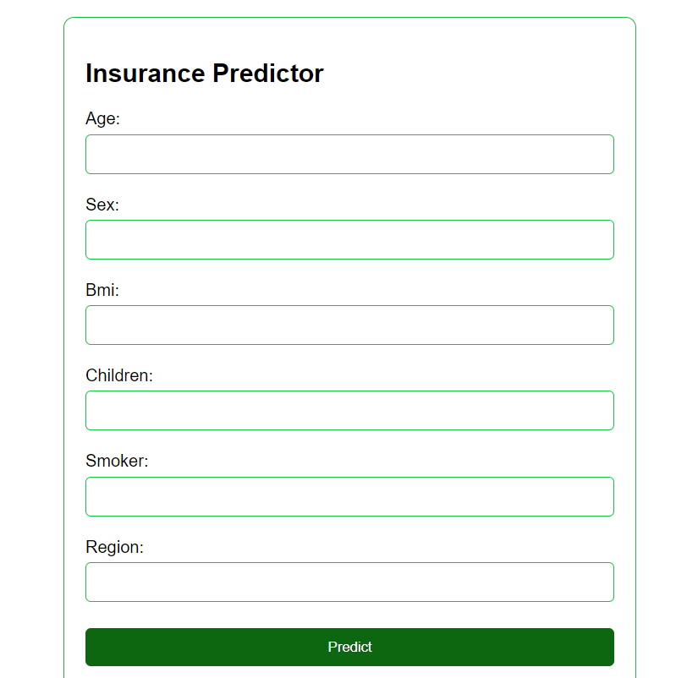

1. Now User has to Enter the details in the empty boxes.

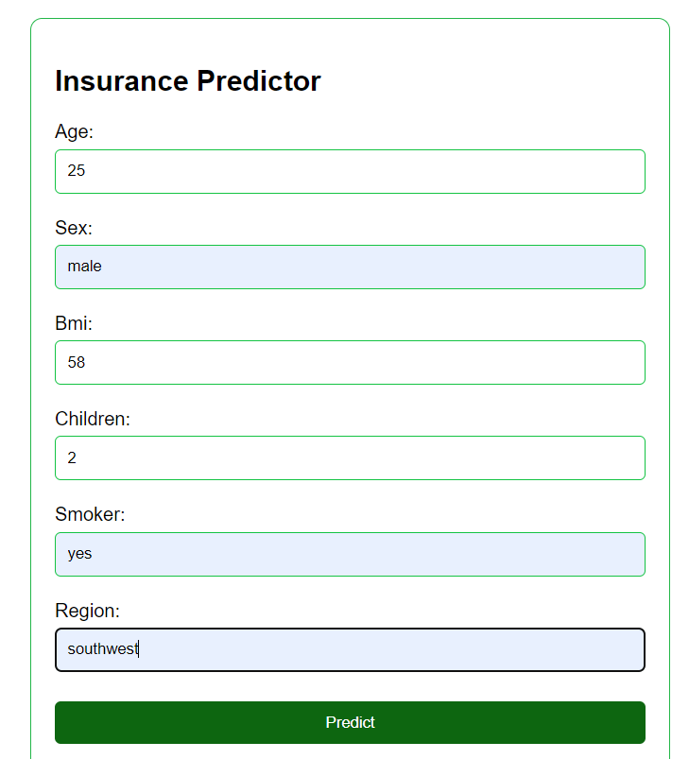

1. After clicking the Predict button, the user will be redirected to another results page where they will be able to see the estimated insurance expenses or the amount of coverage they require.

